Isolation 2.0
Renewing our focus on basic infection prevention
Tool Kit

Overview Section Key points:

Situation
Starting April 8, 2019, patients who have been identified with Methicillin Resistant Staphylococcus aureus (MRSA) or Vancomycin Resistant Enterococcus (VRE) will no longer be placed in isolation using Contact precautions (CP). Team members will focus on basic infection prevention practices with ALL patients.
The basic infection prevention practices include:
- Hand hygiene
- Standard precautions (applying and removing personal protective equipment (PPE)
- Environmental hygiene (cleaning/disinfection of surfaces and non-dedicated equipment)
- Patient hygiene (daily patient bathing and linen changes except on day of admission and discharge)

Please note: This change excludes Bloomington and Paoli

Rationale: This new practice is an innovation that is beyond the current community standard. IU Health facilities, like other academic health centers around the country, are leading efforts to show this change in practice is effective. We will review the data and continue to evaluate the data to move toward a consistent approach.

Why are we making this change?
- Historically the best practice to prevent and control multi-drug resistant organisms was to identify patients with resistant organisms and isolate. This practice has led to a high prevalence of isolation within IU Health facilities.
- Over the last several years, there has been a growing body of evidence demonstrating that healthcare facilities, including large academic centers, have eliminated Contact Precautions for MRSA and VRE without increasing infections. Facilities that have eliminated Contact Precautions focused on reliable performance of basic infection prevention practices such as hand hygiene, environmental hygiene, standard precautions and patient hygiene (Edmonds, 2105, Lemieux, 2017, Huang, 2013).
- A recent publication reported that after the elimination of Contact Precautions for MRSA and VRE, the facility found no significant change in the rate of infectious adverse events; however, they did find a 72% reduction of noninfectious adverse events in patients with MRSA and VRE (Rupp, 2017).
- Patients in isolation are at a higher risk for:
  - adverse events
    - Two studies compared adverse events in patients in Contact Precautions compared to those not in isolation. Those in Contact Precautions had 50% more adverse events in spite of the patients being housed in the same room
  - anxiety, depression and lower patient satisfaction
  - less visits from care providers
    - patients in CPs are seen half as frequently as their counterparts not in isolation

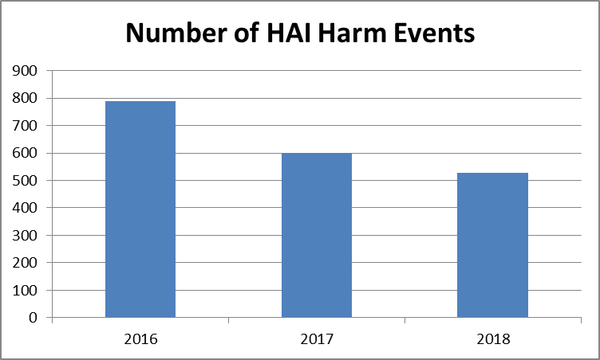
- Finally, IU Health has successfully reduced our HAIs for three consecutive years demonstrating our team members’ ability to perform basic infection prevention practices reliably.

IU Health will continue isolation procedures for specific diseases
  - Patients with highly resistant organisms, such as Carbapenem Resistant Enterobacteriaceae (CRE), will continue to be placed in isolation using Contact Precautions.
  - Patients that are in isolation will continue to have a sign posted on the door of their room.
  - Team members, regardless of their role, should adhere to precautions as posted.
  - We anticipate this change will improve adherence to CPs with these high-risk patients.

What will we be monitoring during the change?
  - All basic practices will be monitored at the system level and results will be reported for:
    - Hand hygiene compliance
    - Standard precautions
    - Environmental hygiene
    - Patient hygiene
  - Infection Prevention will be closely monitoring HAI rates across the system

Refer to local policies for details on specific policies and procedures:
- Hand hygiene
- Standard Precautions and Transmission Based Precautions
- Patient bathing protocols

Team members can find tools and education for Isolation 2.0 on the team portal infection prevention page.

Key Tools for Isolation 2.0
Name | Tool
Communication Plan | 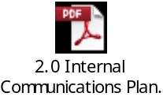
IU Health Minimal Standards for Isolation 2.0 | 
Education Express | 
One page flyer | 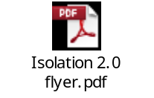
SBAR for meetings | 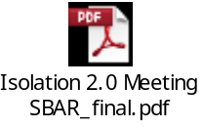
Local Planning and Gap Assessment Tool | 
Rounding questions | 
Patient Education (Notice to MRSA and VRE patients) | 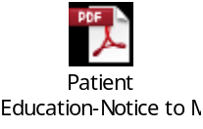
Available Patient Education on MDROs and Contact Isolation | 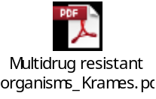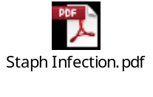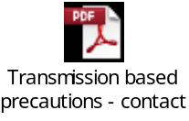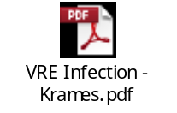
Power point presentation | 
Video education | Click Here

Hand Hygiene Key Points:
- You've heard the facts before. Each year, poor hand hygiene at healthcare facilities causes 99,000 deaths and $45 billion in extra costs—and that’s just here in the United States. As simple as it may seem, proper hand hygiene is the best way to prevent the spread of hospital-acquired infections, but every year in the U.S. one in every 20 hospitalized patients gets an infection.
- How IU Health Promotes Good Hand Hygiene Practices
  - At IU Health, hand hygiene is one important way we keep our patients safe. All IU Health team members should clean their hands at critical moments when germs can be spread and speak up when others may have missed a key moment for hand hygiene. Everyone is part of the hand hygiene program.
  - Hand Hygiene Observer Toolkit – IU Health has an anonymous hand hygiene observer program to improve compliance; toolkit includes onboarding materials, frequently asked questions, observer data entry instructions and more.
  - Hand Hygiene Point Person Toolkit – IU Health has identified a hand hygiene point person at each facility to serve as the contact for hand hygiene.
- When to clean your hands?
  - Everyone should always clean their hands when entering and exiting patient rooms/zones
  - Clinical caregivers will also wash their hand before doing clean tasks, after dirty tasks and before accessing supplies within the room/zone.
- Gloves do not replace hand hygiene as removing gloves actually contaminates your hands.
- Alcohol hand rub is preferred unless your hands are soiled or when caring for a patient in Enteric Precautions.
- All team members should routinely apply lotion that is approved by the hospital. All units should have lotion available for team members’ use.
- Team members are expected to wash their hands many times a day without interruptions and other distractions. All team members are expected to speak up when they see someone miss cleaning their hands on entry or exit. A simple hand washing nonverbal cue is all that is needed! Hand hygiene is a team sport!
- Team members with hand sensitivity should report issue to Employee Occupational Health.

Key Tools for Hand Hygiene
Name | Tool
5 Moments of Hand Hygiene | 
Behavior Care 5 Moments of Hand Hygiene | 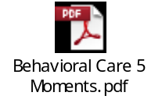
Patient Zone Flyer and PowerPoint | 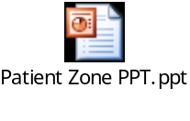
Why Moment 4? | 
Patient Hand Hygiene Brochure | 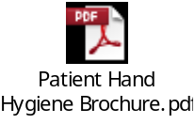
Hand Hygiene Poster | 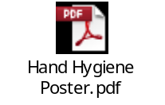
Team Members Must Do’s | 
Hand Hygiene FAQ | 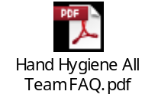
Hand Hygiene Competency | 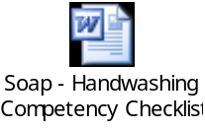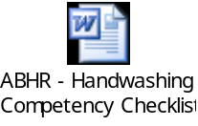
Hand Hygiene video on how to wash | 

Standard Precautions Key Points:
- Standard precautions are used for the care of all patients. They are based on a risk assessment and make use of common sense practices and personal protective equipment (PPE) use that protect healthcare providers from infection and prevent the spread of infection from patient to patient. (CDC)
- Previously called “universal precautions”
- Assumes blood and body fluid of any patient could be infectious
- Decisions about PPE use determined by type of clinical interaction with patient
- Standard precautions and hand hygiene are the primary way team members protect themselves from germ transmission
- Standard precautions include:
  - 5 Moments of hand hygiene
  - Applying and removing personal protective equipment
    - Team members should always remove PPE before exiting the patient room or zone unless providing direct care. Gloves and gowns should not be seen in corridors.
    - PPE should be readily available for use
  - Respiratory hygiene or covering your cough/sneeze
- PPE use for standard precautions
- Gloves: Use during contact with blood, body fluids, secretions, excretions, contaminated items, mucus membranes and non-intact skin:
  - Patient with open/draining wound
  - Starting or removing an IV
  - Cleaning up body fluids
  - Performing patient care activities such as pericare, mouth care, etc.
  - Handling contaminated items
- Gowns: Use during procedures and patient care activities when contact of clothing and exposed skin with blood/body fluids, secretions or excretions is anticipated:
  - Handling contaminated items
  - Changing dressing on open wound with dressing not contained
  - Bathing a complete assist patient
- Masks/Goggles/Face Shield: Use during patient care activities likely to generate splashes or sprays of blood, body fluids, secretions and excretions:
  - Suctioning
  - Obtaining a test that produces a cough
  - Close contact with a coughing patient

Key Tools for Standard Precautions
Name | Tool
Standard Precaution Presentation | 
Standard Precautions Procedure | 
Standard Precaution Competency | 
Supply List | 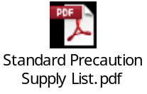

Environmental Hygiene Key Points:
- All team members need to know how to clean equipment correctly
- Any equipment that is not dedicated to the patient should be cleaned after use. If equipment is stored
- Always follow the manufacturer’s instructions for cleaning
- Follow the label on how to use the disinfectants
- IU Health uses OneSource, which provides instructions for use for all medical and surgical equipment
- If there is soiling, you must first clean off the soil and then disinfect using a second task wipe
- Every location should have a service level agreement with EVS so everyone is clear on who cleans what equipment
All facilities should have a process for identifying clean and/or dirty medical equipment that is shared between patients. A visual cue, such as plastic bag, is an example of a best practice.

Key Tools for Environmental Hygiene
Name | Tool
EVS Minimal Standards for Room Cleaning | 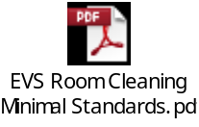
EVS Quality Monitoring Form | 
EVS Quality Monitoring Job Aide | 
Service Level Agreement Sample | 
List of high touch surfaces | 
OneSource Hot Topic | 

Patient Hygiene Key Points:
- CHG Bathing
  - All patients to receive daily bath. CHG should be considered for patients at high risk with a central line or urinary device. CHG use determined locally.
  - Daily bathing with Chlorhexidine bathing products (Hibiclens foam or Sage CHG wipes) can help prevent hospital acquired infections like central line blood stream infections and catheter associated urinary tract infections. CHG produces persistent antibacterial effect on the skin that reduces bacterial colonization if used correctly.
- Routine Bathing
- A routine bath is performed with a hospital approved bathing products if:
- Your unit or facility uses the Sage CHG medicated wipes
- Your facility does not participate in using chlorhexidine
- The patient has a documented allergy to chlorhexidine
- Bathing Equipment
  - Gloves
  - Patient gown
  - Bathing products (determined locally)
  - Optional products: PPE, skin protectant, moisture barrier.
  - Note: if bath basins used- use once and discard
- Linen Changes
  - Linen to be changed daily excluding the day of admission and discharge (includes top and bottom sheet and pillow case at a minimum)
  - Each facility will determine which locations are excluded such as ambulatory or short stay
  - It is encouraged that daily linen change occurs in patients with devices or surgical incisions.
  - Document linen change
- Bathing Documentation
  - Document bath and linen change per local standard
  - Or: I/O/I-Flowsheet->Routine Care->Hygiene->Routine Hygiene->Bath, Medicated or Bath, Routine
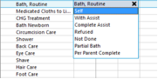

Key Tools for Patient Hygiene
Name | Tool
Lippincott Bathing Procedure | 
Lippincott Bathing Competency | 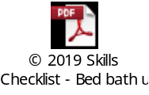
How to use CHG | 

References:
Edmonds, M. (2105). The impact on discontinuing Contact Precautions for MRSA and VRE on device related infections. Infection Control & Hospital Epidemiology, 978-980.
Huang, S. (2013). Targeted versus Universal Decolonization to Prevent ICU Infection. New England Journal of Medicine, 2255-2263.
Lemieux, C. (2017). Longitudinal Multicenter Analysis of Outcomes After Cessation of Control Measures for Vancomycin Resistant Enterococcus. Infection Control & Hospital Epidemiology, 24-30.
Morgan, D. (2009). Adverse outcomes associated with contact precautions: A Literature Review. American Journal of Infection Control, 83-93.
Rupp. (2017). Effect of Cessation of Contact Isolation for Endemic MRSA and VRE. Infection Control & Hospital Epidemiology, 1005-1007.

